PAGE REPLACEMENT:
NEED FOR PAGE REPLACEMENT:
- Page replacement is basic to demand paging
- If a page requested by a process is in memory, then the process can access it. If the requested page is not in main memory, then it is page fault.
- When there is a page fault the OS decides to load the pages from the secondary memory to the main memory. It looks for the free frame. If there is no free frame then the pages that are not currently in use will be swapped out of the main memory, and the desired page will be swapped into the main memory.
- The process of swapping a page out of main memory to the swap space and swapping in the desired page into the main memory for execution is called as Page Replacement.
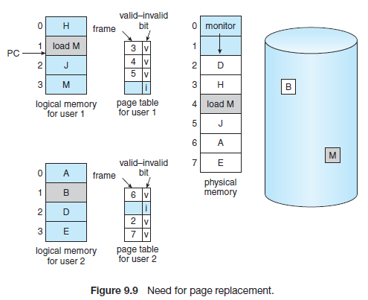

STEPS IN PAGE REPLACEMENT:
1. Find the location of the desired page on the disk.
2. Find a free frame:
a. If there is a free frame, use it.
b. If there is no free frame, use a page-replacement algorithm to select a victim frame.
c. Write the victim frame to the disk; change the page and frame tables accordingly.
3. Read the desired page into the newly freed frame; change the page and frame tables.
4. Continue the user process from where the page fault occurred.
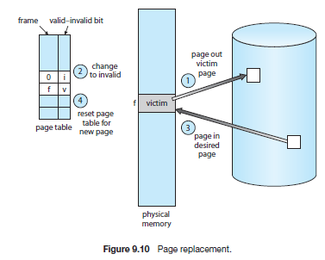
- If no frames are free, two page transfers (one out and one in) are required. This situation effectively doubles the page-fault service time and increases the effective access time accordingly.
- This overhead can be reduced by using a modify bit (or dirty bit).
- When this scheme is used, each page or frame has a modify bit associated with it in the hardware.
- MODIFY BIT: The modify bit for a page is set by the hardware whenever any byte in the page is written into, indicating that the page has been modified.
- When we select a page for replacement, we examine its modify bit. If the bit is set, we know that the page has been modified since it was read in from the disk. In this case, we must write the page to the disk.
- If the modify bit is not set, however, the page has not been modified since it was read into memory. In this case, we need not write the memory page to the disk: it is already there.
PAGE REPLACEMENT ALGORITHMS:
- If we have multiple processes in memory, we must decide how many frames to allocate to each process; and when page replacement is required, we must select the frames that are to be replaced.
- The string of memory references made by a process is called a reference string.
- There are many different page-replacement algorithms that includes
    - FIFO page Replacement
    - Optimal Page Replacement
    - LRU Page Replacement
    - LRU Approximation page Replacement algorithm
    - Counting Based Page Replacement Algorithm
    - Page Buffering Algorithm
- FIFO PAGE REPLACEMENT:
- The simplest page-replacement algorithm is a first-in, first-out (FIFO) algorithm.
- A FIFO replacement algorithm replaces the oldest page that was brought into main memory.
- EXAMPLE: Consider the Reference string 7, 0, 1, 2, 0, 3, 0, 4, 2, 3, 0, 3, 2, 1, 2, 0, 1, 7, 0, 1 for a memory with three frames.
- The three frames are empty initially.
- The first three references (7, 0, 1) cause page faults and are brought into these empty frames.

The algorithm has 15 faults.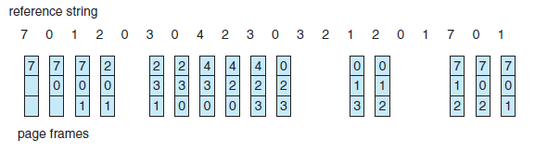
- The next reference (2) replaces page 7, because page 7 was brought in first.
- Page 0 is the next reference and 0 is already in memory, we have no fault for this reference.
- The first reference to 3 results in replacement of page 0, since it is now first in line.
- Because of this replacement, the next reference, to 0, will fault. Page 1 is then replaced by page 0. The process continues until all the pages are referenced.
Advantages:
- The FIFO page-replacement algorithm is easy to understand and program
Disadvantages:
- The Performance is not always good.
- It Suffers from Belady’s Anomaly.
- BELADY’S ANOMALY: The page fault increases as the number of allocated memory frame increases. This unexpected result is called as Belady’s Anomaly.
- OPTIMAL PAGE REPLACEMENT
- This algorithm has the lowest page-fault rate of all algorithms and will never suffer from Belady’s anomaly
- Optimal page replacement algorithm Replace the page that will not be used for the longest period of time
- EXAMPLE: Consider the Reference string 7, 0, 1, 2, 0, 3, 0, 4, 2, 3, 0, 3, 2, 1, 2, 0, 1, 7, 0, 1 for a memory with three frames.
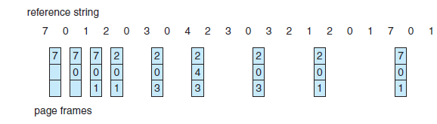
- The Optimal replacement algorithm produces Nine faults
- The first three references cause faults that fill the three empty frames.
- The reference to page 2 replaces page 7, because page 7 will not be used until reference 18, whereas page 0 will be used at 5, and page 1 at 14.
- The reference to page 3 replaces page 1, as page 1 will be the last of the three pages in memory to be referenced again.
Advantages:
- optimal replacement is much better than a FIFO algorithm
Disadvantage:
- The optimal page-replacement algorithm is difficult to implement, because it requires future knowledge of the reference string.

3. LRU PAGE REPLACEMENT
- The Least Recently used algorithm replaces a page that has not been used for a longest period of time.
- LRU replacement associates with each page the time of that page’s last use.
- It is similar to that of Optimal page Replacement looking backward in time, rather than forward.
- EXAMPLE: Consider the Reference string 7, 0, 1, 2, 0, 3, 0, 4, 2, 3, 0, 3, 2, 1, 2, 0, 1, 7, 0, 1 for a memory with three frames.
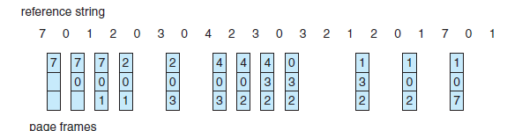
- The LRU algorithm produces twelve faults
- The first three references cause faults that fill the three empty frames.
- The reference to page 2 replaces page 7, because page 7 has not been used for a longest period of time, when we look backward.
- The Reference to page 3 replaces page 1, because page 1 has not been used for a longest period of time.
- When the reference to page 4 occurs, however, LRU replacement sees that, of the three frames in memory, page 2 was used least recently.
- Thus, the LRU algorithm replaces page 2, not knowing that page 2 is about to be used.
- When it then faults for page 2, the LRU algorithm replaces page 3, since it is now the least recently used of the three pages in memory.
Advantages:
- The LRU policy is often used as a page-replacement algorithm and is considered to be good.
- LRU replacement does not suffer from Belady’s anomaly.
Disadvantage:
- The problem is to determine an order for the frames defined by the time of last use.
- Two implementations are feasible:
• Counters. We associate with each page-table a time-of-use field and add to the CPU a logical clock or counter. The clock is incremented for every memory reference. Whenever a reference to a page is made, the contents of the clock register are copied to the time-of-use field in the page-table entry for that page. So we can find the “time” of the last reference to each page.
• Stack. Another approach to implementing LRU replacement is to keep a stack of page numbers. Whenever a page is referenced, it is removed from the stack and put on the top. In this way, the most recently used page is always at the top of the stack and the least recently used page is always at the bottom
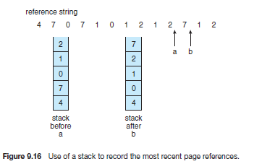
- STACK ALGORITHM: A stack algorithm is an algorithm for which it can be shown that the set of pages in memory for n frames is always a subset of the set of pages that would be in memory with n
+ 1 frames.
4. LRU APPROXIMATION PAGE REPLACEMENT ALGORITHM:

- The system provides support to the LRU algorithm in the form of a bit called Reference bit.
- REFERENCE BIT: The reference bit for a page is set by the hardware whenever that page is referenced (either a read or a write to any byte in the page).
- Reference bits are associated with each entry in the page table.
- Initially, all bits are cleared (to 0) by the operating system. As a user process executes, the bit associated with each page referenced is set (to 1) by the hardware.
- After some time, we can determine which pages have been used and which have not been used by examining the reference bits.
- This information is the basis for many page-replacement algorithms that approximate LRU replacement.
a) Additional-reference-bits algorithm
- The additional ordering information can be gained by recording the reference bits at regular intervals. We can keep an 8-bit byte for each page in a table in memory.
- At regular intervals (say, every 100 milliseconds), a timer interrupt transfers control to the operating system.
- These 8-bit shift registers contain the history of page use for the last eight time periods.
- If the shift register contains 00000000, for example, then the page has not been used for eight time periods.
- A page that is used at least once in each period has a shift register value of 11111111.
- A page with a history register value of 11000100 has been used more recently than one with a value of 01110111.
- Thus the page with the lowest number is the LRU page, and it can be replaced.
b) Second-Chance Algorithm:
- The basic algorithm of second-chance replacement is a FIFO replacement algorithm.
- When a page has been selected, however, we inspect its reference bit.
- If the value is 0, we proceed to replace this page; but if the reference bit is set to 1, we give the page a second chance and move on to select the next FIFO page.
- When a page gets a second chance, its reference bit is cleared, and its arrival time is reset to the current time. Thus, a page that is given a second chance will not be replaced until all other pages have been replaced
- One way to implement the second-chance algorithm is as a circular queue.
- A pointer indicates which page is to be replaced next. When a frame is needed, the pointer advances until it finds a page with a 0 reference bit.
- Once a victim page is found, the page is replaced, and the new page is inserted in the circular queue in that position
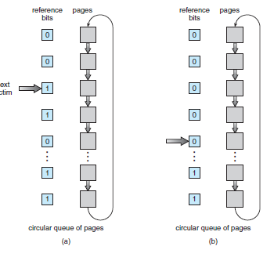
c. Enhanced Second-Chance Algorithm
- We can enhance the second-chance algorithm by considering the reference bit and the modify as an ordered pair
- The order is {Reference bit, Modify bit}
- we have the following four possible classes:
    - (0, 0) neither recently used nor modified—best page to replace
    - (0, 1) not recently used but modified—not quite as good
    - (1, 0) recently used but clean—probably will be used again soon
    - (1, 1) recently used and modified—probably will be used again soon, and the page will be need to be written out to disk before it can be replaced
- Here we give preference to those pages that have been modified in order to reduce the number of I/Os required. Thus the modified pages will not be replaced before writing it to the disk.
5. COUNTING-BASED PAGE REPLACEMENT
- We can keep a counter of the number of references that have been made to each page.
- This method includes two schemes
- Least frequently used (LFU) page-replacement: The least frequently used (LFU) page-replacement algorithm requires that the page with the smallest count be replaced. The reason for this selection is that an actively used page should have a large reference count.
- Most frequently used (MFU) page-replacement algorithm: The most frequently used (MFU) page-replacement algorithm is based on the argument that the page with the smallest count was probably just brought in and has yet to be used.
6. PAGE BUFFERING ALGORITHM:
- systems commonly keep a pool of free frames
- When a page fault occurs, a victim frame is chosen as and the desired page is read into a free frame from the pool before the victim is written out.
- This procedure allows the process to restart as soon as possible, without waiting for the victim page to be written out. When the victim is later written out, its frame is added to the free-frame pool.
- Whenever the paging device is idle, a modified page is selected and is written to the disk. Its modify bit is then reset.
- This scheme increases the probability that a page will be clean when it is selected for replacement

ALLOCATION OF FRAMES:
- Allocation of frames deals with how the operating system allocates the fixed amount of free memory among the various processes.
- Consider a single-user system with 128 KB of memory composed of pages 1 KB in size.
- This system has 128 frames. The operating system may take 35 KB, leaving 93 frames for the user process.
- Under pure demand paging, all 93 frames would initially be put on the free-frame list. When a user process started execution, it would generate a sequence of page faults.
- The first 93 page faults would all get free frames from the free-frame list. When the free-frame list was exhausted, a page-replacement algorithm would be used to select one of the 93 in-memory pages to be replaced with the 94th, and so on.
- When the process terminated, the 93 frames would once again be placed on the free-frame list.
- Operating system allocates all its buffer and table space from the free-frame list.
- When this space is not in use by the operating system, it can be used to support user paging.
- Minimum Number of Frames
- OS cannot allocate more than the total number of available frames (unless there is page sharing).
- It must also allocate at least a minimum number of frames as required by the process.
- The reason for allocating at least a minimum number of frames involves performance. As the number of frames allocated to each process decreases, the page-fault rate increases, slowing process execution.
- Consider a machine in which all memory-reference instructions may reference only one memory address. We need at least one frame for the instruction and one frame for the memory reference.
- If one-level indirect addressing is allowed (for example, a load instruction on page 16 can refer to an address on page 0, which is an indirect reference to page 23), then paging requires at least three frames per process.
- The worst-case scenario occurs in computer architectures that allow multiple levels of indirection.
- To overcome this difficulty, we must place a limit on the levels of indirection.
- When the first indirection occurs, a counter is set to the maximum number of indirections allowed; the counter is then decremented for each successive indirection for this instruction. If the counter is decremented to 0, a trap occurs.
- The minimum number of frames is defined by the computer architecture and the maximum number is defined by the amount of available physical memory.
b) Allocation Algorithms
- The Operating system makes use of various allocation algorithms to allocate the frames to the user process.
    - Equal Allocation
    - Proportional Allocation
- EQUAL ALLOCATION: The easiest way to split m frames among n processes is to give everyone an equal share, m/n frames.
- If there are 93 frames and five processes, each process will get 18 frames. The three leftover frames can be used as a free-frame buffer pool. This scheme is called equal allocation.
- DISADVANTAGE: Consider a system with a 1-KB frame size. If a small student process of 10 KB and an interactive database of 127 KB are the only two processes running in a system with 62 free frames, each process will be allocated with 31 frames.
- The student process does not need more than 10 frames, so the other 21 are wasted.
- PROPORTIONAL ALGORITHM: The Os allocates the available memory to each process according to its size.
- Let the size of the virtual memory for process pi be si , given by
- If the total number of available frames is m, we allocate ai frames to process pi, where ai is approximately ai = si/S × m.
- Consider a system with a 1-KB frame size. If a small student process of 10 KB and an interactive database of 127 KB are the only two processes running in a system with 62 free frames.
- we would split 62 frames between two processes, one of 10 pages and one of 127 pages, by allocating 4 frames and 57 frames, respectively, since
10/137 × 62 ≈ 4, and
127/137 × 62 ≈ 57.
- Thus both processes share the available frames according to their “needs,” rather than equally.
- A high-priority process is treated the same as a low-priority process.
- we may want to give the high-priority process more memory to speed its execution, to the detriment of low-priority processes.
- One solution is to use a proportional allocation scheme wherein the ratio of frames depends not on the relative sizes of processes but rather on the priorities of processes or on a combination of size and priority.
c) Global versus Local Allocation
- Another important factor in the way frames are allocated to the various processes is page replacement.
- page-replacement algorithms are divided into two broad categories:
    - global replacement
    - local replacement.
- Global replacement allows a process to select a replacement frame from the set of all frames, even if that frame is currently allocated to some other process;
- Local replacement requires that each process select from only its own set of allocated frames.
- EXAMPLE: consider an allocation scheme where in we allow high-priority processes to select frames from low-priority processes for replacement.
- A process can select a replacement from among its own frames or the frames of any lower-priority process. This approach allows a high-priority process to increase its frame allocation
- One problem with a global replacement algorithm is that a process cannot control its own page-fault rate. The set of pages in memory for a process depends not only on the paging behavior of that process but also on the paging behavior of other processes.
- In local replacement, the set of pages in memory for a process is affected by the paging behavior of only that process.
d) Non-Uniform Memory Access
- In some systems, a given CPU can access some sections of main memory faster than it can access others. These performance differences are caused by how CPUs and memory are interconnected in the system.
- A system is made up of several system boards, each containing multiple CPUs and some memory.
- The CPUs on a particular board can access the memory on that board with less delay than they can access memory on other boards in the system.
- The systems in which the memory access time are uniform is called as Uniform memory access.
- Systems in which memory access times vary significantly are known collectively as non-uniform memory access (NUMA) systems, and they are slower than systems in which memory and CPUs are located on the same motherboard.
- Managing which page frames are stored at which locations can significantly affect performance in NUMA systems.
- If we treat memory as uniform in such a system, CPUs may wait significantly longer for memory access.
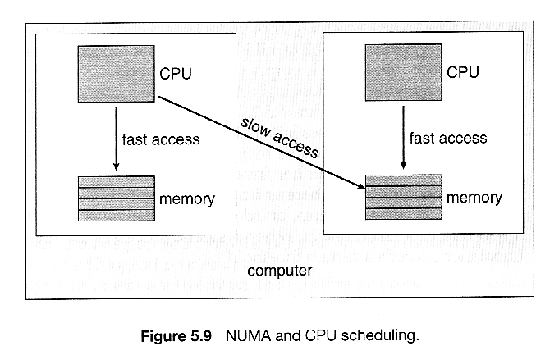

- The goal is to have memory frames allocated “as close as possible” to the CPU on which
the process is running so that the memory access can be faster.
- In NUMA systems the scheduler tracks the last CPU on which each process ran. If the scheduler tries to schedule each process onto its previous CPU, and the memory-management system tries to allocate frames for the process close to the CPU on which it is being scheduled, then improved
cache hits and decreased memory access times will result.

